**Project Design Phase-2**

**Data Flow Diagram & User Stories**

|  |  |
| --- | --- |
| Team ID | PNT2022TMID40035 |
| Project Name | Smart Crop Production System for Agriculture |

**Data Flow Diagram:**

A Data Flow Diagram (DFD) is a traditional visual representation of the information flows within a system. A neat and clear DFD can depict the right amount of the system requirement graphically. It shows how data enters and leaves the system, what changes the information, and where data is stored.

DFD for smart waste management System for metropolitan cities.

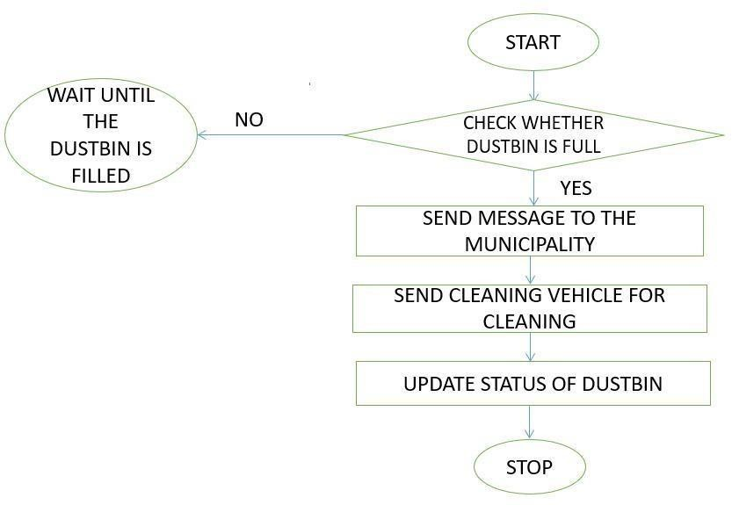 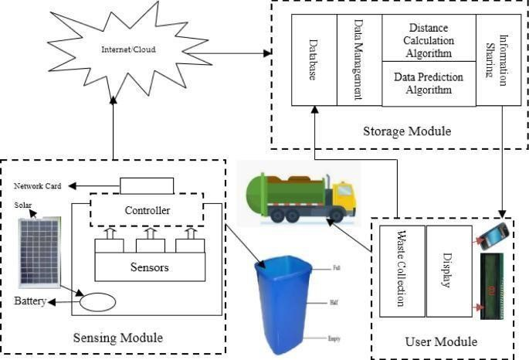

**User Stories:**

Use the below template to list all the user stories for the product.

|  |  |  |  |  |  |  |
| --- | --- | --- | --- | --- | --- | --- |
| **User Type** | **Functional**  **Requirement (Epic)** | **User Story**  **Number** | **User Story / Task** | **Acceptance criteria** | **Priority** | **Release** |
| Authorised Person(Manages web app) | Login | USN-1 | As an authorised person, I gave user id and password for every workers and manage them. | I can access web page /dashboard | Medium | Sprint-2 |
| Admin | Login | USN-2 | As a admin, I will manage garbage level monitor. When garbage gets filling alert, I will post location and garbage Id to trash truck. | I can manage garbage monitoring. | High | Sprint-1 |
| Truck Driver | Login | USN-3 | As a driver, I’ll follow the route sent by user to reach the filled garbage location. | I can drive to reach the garbage filled route in dynamic route given. | Medium | Sprint-2 |
| Garbage Collector | Login | USN-4 | As a garbage collector, I’ll collect all the garbage from garbage bin and load it to the truck and send them to landfill. | I can collect garbage and pulled to truck. | Medium | Sprint-2 |
| Municipality | Login | USN-5 | As a municipality, I’ll check the process are happening in discipline manner without any issues. | I can manage all the process going good. | High | Sprint-1 |